Computational Design of a Multiepitope Vaccine
Targeting TMOD3 in Pancreatic Cancer
Melika Janmohammadifiroz, Department of Biology, Faculty of Basic Sciences, Islamic Azad University, Qaemshahr Branch, Qaemshahr, Iran; E-Mail: melikajanmohammadifiroz@gmail.com

Abstract
Between 1990 and 2017, the number of pancreatic cancer cases increased from 196,000 to 441,000. Despite advances in therapy, pancreatic adenocarcinoma (PAAD) remains one of the deadliest cancers, with a 5-year survival rate of approximately 10%. This study aimed to design a suggested multi-epitope vaccine candidate targeting pancreatic cancer. TMOD3 is effective in the progression of PAAD cells as an independent risk factor. Through this study, a novel multi-epitope vaccine construct against TMOD3 is designed using various immunoinformatic and bioinformatic web servers. Moreover, a C-terminal of Mycobacterium tuberculosis HSP70 adjuvant was added to the vaccine construct to enhance its immunogenicity. Then, the epitope and the whole structure were evaluated using computational tools from various aspects, including antigenicity, allergenicity, toxicity, and others. The final multi-epitope vaccine structure was predicted, and the quality was evaluated using various web servers. The multi-epitope vaccine construct was subjected to molecular docking with B7-1. Finally, the 100 ns molecular dynamics simulation of vaccine complexes and other structural and thermodynamic features were analysed the vaccine candidate demonstrated structural stability and its stable complex with the receptor. The selected epitopes for the vaccine construct were predicted to be non-allergenic, non-toxic, and antigenic. According to the results of the vaccine evaluation, the proposed vaccine structure is expected to be effective against pancreatic cancer. Additional monitoring through in vitro and in vivo experiments is required to evaluate the efficiency of vaccination performance, even though the computational assays provided reliable results.
Keywords: Pancreatic cancer, Vaccine design, Epitope, Multi epitope vaccine, Bioinformatics

Introduction
Pancreatic cancer cases have doubled over the past two decades annually, and it has increased from 196,000 patients worldwide to 441,000 from 1990 to 2017 [1]. Despite all advanced therapies, pancreatic adenocarcinoma (PAAD) is one of the most lethal human malignancies with a 5-year survival rate of only 10% [2]. According to a 2012 report, people over the age of 65, comprising 8% of the global population, were most vulnerable to pancreatic cancer [3]. Thirty years later, this percentage is anticipated to increase to 16.7% [3]. The early diagnosis of this disease is challenging [4]. Unfortunately, pancreatic cancer does not present any symptoms in the early stages [2]. Usually, more than 80 percent of patients will be diagnosed in the advanced or metastatic stage which makes surgical intervention unfeasible [2]. Moreover, this type of cancerous tumour is intrinsically resistant to chemotherapy and the immune system attacks [5]. Strategies like combined chemotherapy, molecularly targeted drugs, and immune checkpoint blockade are not certainly effective in enhancing the prognosis [5]. This emphasizes the need to discover a vaccine to prohibit pancreatic cancer in the population who are potentially at risk of the disease. However, vaccine design is a time-consuming process, and Bioinformatic approaches make it fast. The tropomodulin (TMOD) family of proteins includes four isoforms: tropomodulin-1, tropomodulin-2, tropomodulin-3, and tropomodulin-4 (TMOD1, TMOD2, TMOD3, and TMOD4). In addition to this, TMOD3 proteins have special attributes that allow them to bind the tropomyosin (TPM)-fibros(F)-actin and simple F-actin tips. Additionally, the regulation of the specialized TPM-F-actin network will be selective by TMOD3. TMOD3 also binds to actin, and its function is regulated by Akt2 phosphorylation. Moreover, it is associated with important cellular processes such as cell migration, exocytosis, and development [6]. Approximately in all mammalian cells TMOD3 is expressed. TMOD3 also has an essential impact on cytoskeletal stress fibers preservation, pseudopods formation and epithelial cell polarity regulation [7] [8]. TMOD3 can make tumor cells more aggressive and show metastatic features [9]. Moreover, high levels of TMOD3 expression in hepatocellular carcinoma have been correlated with poor prognosis [10]. Tropomodulin 3 (TMOD3) has a crucial impact on the development of various tumors [11] [12] [13] [14]. In the study by Bin Zhong et al, TMOD3 was demonstrated to be effective in the progression of PAAD cells, which is considered an independent risk factor for PAAD progression [5]. In a recent study, researchers knocked down TMOD3, resulting in increased sensitivity to ferroptosis agonists in pancreatic cancer cells with KRAS mutations. Additionally, they also targeted TMOD3 using a pharmacological approach and found that this raised the sensitivity level to ferroptosis agonists and enhanced responsiveness to PD-1 antibodies. Consequently, they suggested TMOD3 as a novel target in pancreatic cancer treatment [15]. In the article of Xing Huang et al, the importance of the mRNA vaccine is mentioned [16]. It is highlighted that it is a potential cutting-edge alternative for novel therapeutic in pancreatic cancer with emphasis on its advantages over another conventional vaccine. Moreover, it suggested a strategy to design and apply personalized mRNA vaccines to make pancreatic cancer treatment precise. However, there are challenges to mRNA vaccine design for pancreatic cancer because of its complexity and heterogeneity. In the article of Md. Habib Ullah Masum et al, have constructed an mRNA vaccine for the treatment of Pancreatic ductal adenocarcinoma that has targeted key activators of immune receptors the S100 family proteins using immunoinformatic and reverse vaccinology approaches [17]. The vaccine construct represented a potentially strong immune activation and high stability, solubility, and strong binding affinity for Toll-like receptors. Moreover, it causes memory B-cells and T-cell appearance and increases helper T-cell and immunoglobulins (IgM and IgG). In the article by Sooram Banesh et al., they constructed a multi-epitope vaccine for pancreatic cancer by examining transcriptomics and protein expression databases [18]. After examining 21,054 proteins and they identified 143 proteins. They created 51,840 vaccine constructs using CTL, HTL, and B-cell predicted epitopes. The 37961 construct demonstrated better performance from some aspects including strong immune response induction, stronger interaction and stability with TLR-9, and 100% predicted solubility in the E. coli expression system. In another research, Because of the major role of mutant KRAS-induced tumorigenesis in the progression of various types of cancers including pancreatic, lung, and breast cancer is targeted for designing a novel multi-epitope vaccine construct [19]. Through the study, the vaccine was designed to target KRAS G12D and G12C mutants using reverse vaccinology and immunoinformatic approaches. In the present study, a multi-epitope vaccine targeting TMOD3 is proposed as a potential approach to prevent pancreatic cancer.

2. Material and Methods

2.1. Sequence retrieval
The TMOD3 sequence was retrieved from the Protein Data Bank section in FASTA format from the National Center for Biotechnological Information (NCBI).

2.2. Sequence Evaluation
In the next step, the vaccine target sequence was evaluated for allergenicity and toxicity using the AllerTop web server [20] and the ToxinPred web server [21], respectively, using default parameters. To examine antigenicity, the VaxiJen web server [22] was used, with the sequence output unselected and the summary mode selected. Additionally, the tumour option was chosen from the target organism options, and the rest of the parameters remained in default mode.

2.3. Prediction, Screening, and Selection of Target Protein Epitopes

2.3.1. Prediction of T-cell epitopes
An effective vaccine candidate must be capable of triggering both B cell and T cell immune responses. For the evaluation of MHC I epitopes of T cells, the MHC-I binding prediction tool on the IEDB web server was used. Moreover, in the assessment of MHC II, the MHC-II binding prediction tool on the IEDB web server [23] was used. The 'Select full HLA reference set' parameter was applied to both the MHC I and MHC II binding prediction tools. Additionally, for the MHC II prediction tool, we used an additional parameter, which is the length of the peptide, and it was selected in the range from 12 to 18 amino acids. The rest of the parameters were used in default mode on both web servers.

2.3.2. Prediction, Screening, and Selection of B-cell Epitopes
For the prediction of B-cell epitopes of the TMOD3 protein, the IEDB antibody production web server [23] with score of less than 7 were eliminated, and those with a score of 7 or higher were selected. In the next step, B-cell epitopes were evaluated for toxicity, allergenicity, and antigenicity using the previously mentioned web servers with their previously selected parameters. The web servers predicted the probability of toxicity, being an allergen, and antigenicity using their default parameters. Epitopes that were predicted to be toxins or probably non-antigens were eliminated.

2.3.3. Screening and Selecting T-Cell Epitopes
The VaxiJen web server provided a list of predicted epitopes with their VaxiJen scores for the T-cell epitopes, along with IEDB scores, which were provided by the MHC I and MHC II binding prediction tools for T-cell epitopes. The first 1000 peptides were selected. In this step, the top ten epitopes with the highest IEDB and VaxiJen scores were chosen. The VaxiJen scores were standardized between 0 and 1, similar to the IEDB scores, and then the average was calculated. Those with the highest average scores were considered the best candidates. Another important factor to consider is diversity. The selected epitopes needed to be different, and those with different sequences were prioritized. Consequently, these selected epitopes were then evaluated for toxicity and allergenicity using the previously selected web servers and default parameters. Epitopes that were not toxins and not probable allergens were chosen.

2.4. The construction of the final vaccine structure
The vaccine sequence was constructed by assigning specific peptide linkers to each epitope. For MHCI, the linker was AAY [24], for MHCII, it was GPGPG [24], and for B-cell, the linker was KK [25]. To enhance immunity, the FASTA sequence of the C-terminal of Mycobacterium tuberculosis HSP70 [26] [27]with PDB ID: 7O00 (which is RKPFQSVIADTGIS), was retrieved from RCSB PDB and added as an adjuvant to the beginning and end of the vaccine construct sequence. This sequence was linked with EAAAK [24] as a linker. To express and purify the protein, and 6x-His tag [24] was added.

2.5. Evaluation of the Construct Sequence

2.5.1. Evaluation of Toxicity, Allergenicity, and Antigenicity of the Construct
The sequence was evaluated for its immunological attributes, including toxicity, allergenicity, and antigenicity. This assessment was conducted using the ToxinPred, AllerTop web server, and VaxiJen web servers, respectively. Based on selected parameters, the servers predicted the likelihood of toxicity, allergenicity, and antigenicity.

2.5.2. Evaluation of Chemical and Physical Properties of the Construct
The ProtParam tool from the Expasy web server was used to evaluate the chemical and physical properties of the construct [28]. Different qualities of this sequence, including the Instability index, number of amino acids, molecular weight, aliphatic index, extinction coefficient, theoretical PI, amino acid composition, and hydrophobicity (GRAVY), were evaluated.

2.5.3. Evaluation of the Secondary Structure
The secondary structure of the construct was predicted with the Prabi web server, which utilized the MLRC algorithm, and the default parameters were selected [29], [30]. Then, the percentage of alpha helices was examined to check whether it met the desired level. The web server also provided other important information.
2.5.4. Vaccine Candidate Modeling
The sequence of the vaccine candidate was modeled using the AlphaFold server [31]. This is a state-of-the-art tool for protein structure prediction using deep learning algorithms. The model was refined by the GalaxyWEB server [32], which utilizes an iterative optimization method to improve the stereochemical quality and energy landscape of the protein structure. Refinement was performed to correct potential structural inaccuracies and enhance the overall quality of the model. Several validation metrics were used to assess the quality of both the initial and refined models. The VADAR v1.8 server computed The Ramachandran plot, Stereo/Packing Quality Index, and 3D Profile Quality Index. Ramachandran plots were used to assess the stereochemical quality of the models by analyzing the distribution of phi (φ) and psi (ψ) dihedral angles. The models' overall structural integrity and stereochemical accuracy are revealed by the Stereo/Packing Quality and the 3D Profile Quality indices. The Stereo/Packing Quality and the 3D Profile Quality indices provide insights into the stereochemical accuracy and overall structural integrity of the models. Additionally, the ERRAT score was calculated using the SAVES v6.1 server [33] [34][35][36] to evaluate the non-bonded atomic interactions within the models. Compared to the initial model, improvements in these quality metrics confirmed the validity of the refinement process.

2.6. Receptor-Vaccine Docking
The refined vaccine model was docked against the B7-1 (PDB ID 1DR9)[37], which served as the receptor, using the ClusPro 2.0 server [38][39][40][41][42]. ClusPro uses a rigid-body docking algorithm and then clusters the generated poses to find the most energetically favorable interactions.

2.7. Molecular dynamics (MD) simulation
The molecular dynamics (MD) simulation is a crucial step for assessing a protein's stability under various thermobaric circumstances. As a result, the MD simulation was performed using the GROMACS 2023.4 software package [43] and all-atom CHARMM36 force field in combination with the TIP3P water model. Suitable amounts of Na⁺ and Cl⁻ ions were added which achieved the system neutralization and physiological ionic strength of 0.14 M. The steepest descent integrator with the Verlet cutoff strategy initially performed the energy minimization for relaxation of internal restrictions until the system converged (the greatest force dropped below 1000.0 kJ/-mol/nm). After that, the equilibration process in the Canonical (NVT) and Isobaric (NPT) ensembles was carried out under positional restraint for 500 and 1000 ps, respectively. V-rescale, a modified Berendsen thermostat was utilized to maintain constant volume and temperature at 300 K. Similarly, a C-rescale pressure coupling algorithm was applied to maintain constant pressure at 1 bar. Eventually, an MD production run was performed for 100 ns with a 2 fs time step under conditions of 310 K and 1 bar. The Nosé-Hoover thermostat and the Parrinello-Rahman barostat algorithms were used to determine the temperature and pressure coupling during the production runs. The equations of motion were integrated using the leap-frog algorithm, maintaining all bonds constrained with the LINCS algorithm. Utilizing the Particle Mesh Ewald technique, long-range electrostatic interactions were assessed. Long-range electrostatic interactions were evaluated using the Particle Mesh Ewald method. The trajectories generated were evaluated using in-built Gromacs utilities.

3. Results

3.1. Screening the Selected Protein Target
The TMOD3 protein was retrieved from the protein section of the NCBI database, and the sequence of TMOD3 was evaluated for toxicity, allergenicity, and antigenicity using the ToxinPred, AllerTOP, and VaxiJen servers, respectively, with default parameters. For the VaxiJen web server, the tumor option was selected, and the sequence output option was deselected. The TMOD3 protein sequence was predicted to be probably non-toxic, non-allergenic, and antigenic.

3.2. Screening and Prediction of T-cell Selected Epitopes

MHC I and II binding tools evaluated the TMOD3 epitopes, and then the provided epitopes were filtered for toxicity, allergenicity, and antigenicity using the previously mentioned servers and parameters. Epitopes that were probably non-toxic and non-allergenic, with the highest average VaxiJen (standardized to a range between 0 and 1, comparable to IEDB scores.) and IEDB scores, were selected. The selected epitopes were prioritized based on diversity and length.

3.3. Screening and Prediction of B-cell Epitopes

After evaluating peptide B-cell epitopes, those with a length of more than 6 were selected and then evaluated for antigenicity, allergenicity, and toxicity using the previously mentioned servers and parameters. As a result, the NDLVRKKRVEG epitope was finally selected for the construct as it was predicted antigenic, non-toxic, and non-allergenic.

3.4. The Final Structure of the Vaccine Construction
The Final Structure of the vaccine is demonstrated in Figure 1, which includes the seven MHC I epitopes, eight MHC II epitopes, and one B cell. Additionally, it includes two sequences of adjuvant at first and at the end of the sequence with a 6x-His tag.

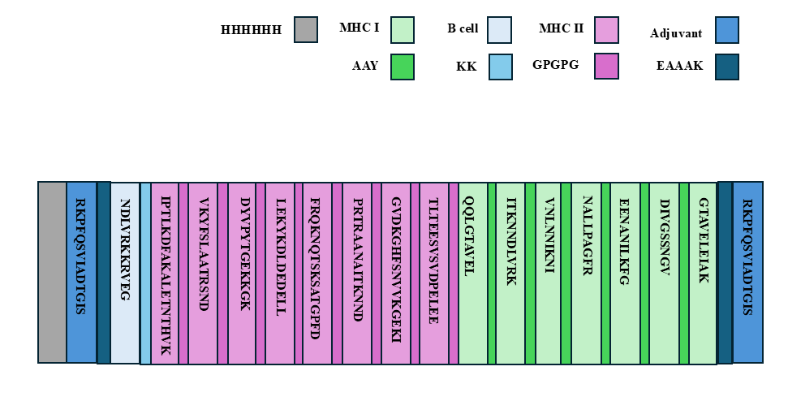
Figure 1. The vaccine construct illustrated in the picture above

3.5. Screening and the Secondary Structure Prediction of the Construct

The sequence of the construct was examined for allergenicity, toxicity, and antigenicity. The construct was found to be probably non-toxic, non-allergenic, and antigenic. After that, the construct sequence was evaluated for physicochemical properties using the ProtParam web server. The results are provided in Table 1. The sequence's instability index was 22.17. Moreover, the secondary structure of the sequence was predicted by the Prabi web server, and the alpha helix index was found to be 26.51%. Additional information is provided in Table 2 and Figure 2.

Table 1. The table below represents the physicochemical properties of the vaccine structure.
Number of amino acids: | 298
Molecular weight: | 31238.95
Theoretical pI: | 8.94
Total number of atoms: | 4393
Extinction coefficients: | This protein does not contain any Trp residues. Experience shows that  this could result in more than 10% error in the computed extinction coefficient.  Extinction coefficients are in units of M⁻¹ cm⁻¹, at 280 nm measured in water.  Ext. coefficient 14900  Abs 0.1% (=1 g/l) 0.477
Estimated half-life: | The N-terminal of the sequence considered is R (Arg).  The estimated half-life is: 1 hours (mammalian reticulocytes, in vitro).  2 min (yeast, in vivo).  2 min (Escherichia coli, in vivo).
Instability index: | The instability index (II) is computed to be 22.17  This classifies the protein as stable.
Aliphatic index: | 69.50
Grand average of hydropathicity (GRAVY): | -0.612

Table 2. Some additional information about the secondary structure of the vaccine is provided in the table below.
Structure | Count | Percentage
Alpha helix (Hh) | 79 | 26.51%
310 helix (Gg) | 0 | 0.00%
Pi helix (Ii) | 0 | 0.00%
Beta bridge (Bb) | 0 | 0.00%
Extended strand (Ee) | 46 | 15.44%
Beta turn (Tt) | 0 | 0.00%
Bend region (Ss) | 0 | 0.00%
Random coil (Cc) | 173 | 58.05%
Ambiguous states | 0 | 0.00%
Other states | 0 | 0.00%

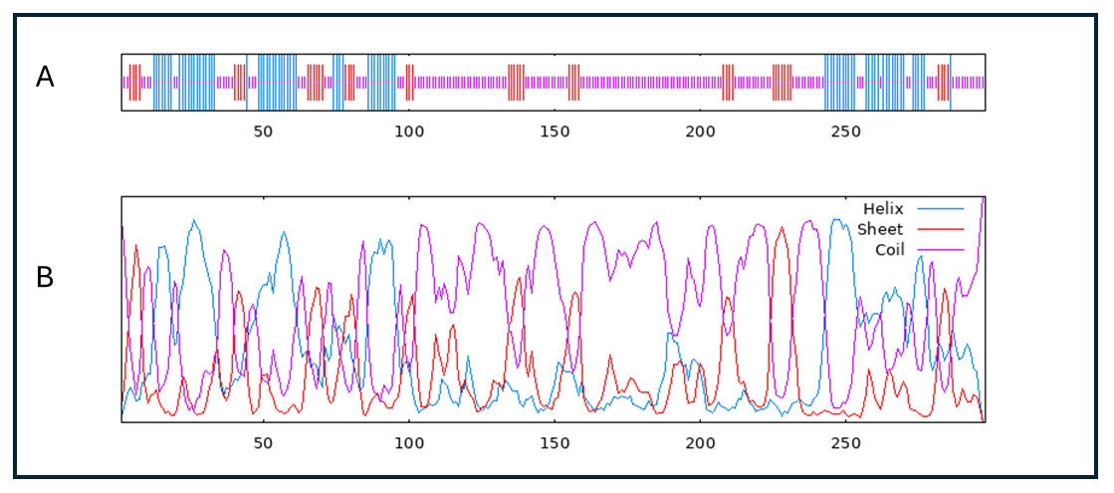
Figure 2. In this figure panel A and panel B, the data of coil, sheet, and helix are merged

3.6. Vaccine Candidate Modeling and Analysis
The vaccine sequence was modeled by applying the AlphaFold server and it is illustrated in the figure 3. The initial model was refined using the GalaxyWEB server. Multiple validation metrics evaluated the quality of both the initial and refined models. VADAR v1.8 server demonstrated the Ramachandran plot, Stereo/Packing Quality Index, and 3D Profile Quality Index in figures 4 and 5 A, B, and C. SAVES v6.1 server was utilized to calculate the ERRAT score in Figures 4 and 5. D.
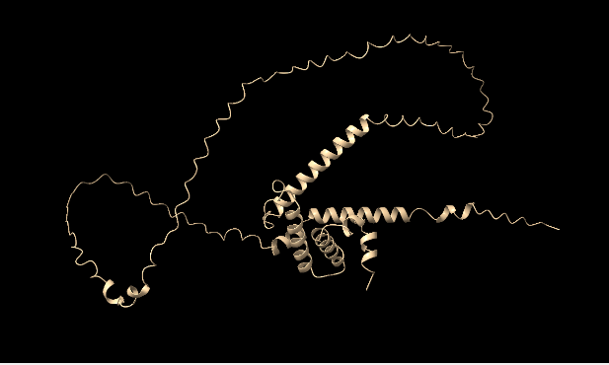
Figure 3. The initial model of vaccine is represented in this picture

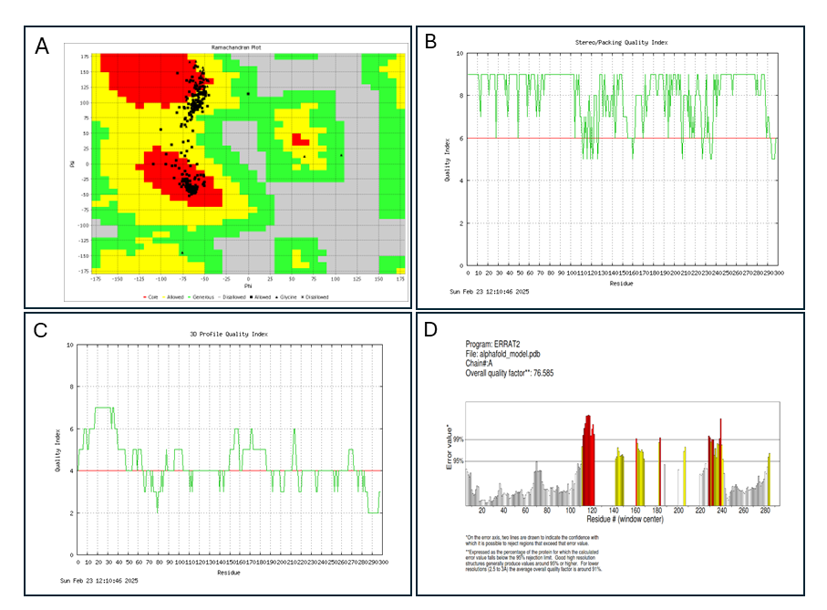
Figure 4. (A) Ramachandran plot, (B) Stereo/Packing Quality Index, (C) 3D Profile Quality Index, and (D) ERRAT plot of the initial vaccine model.
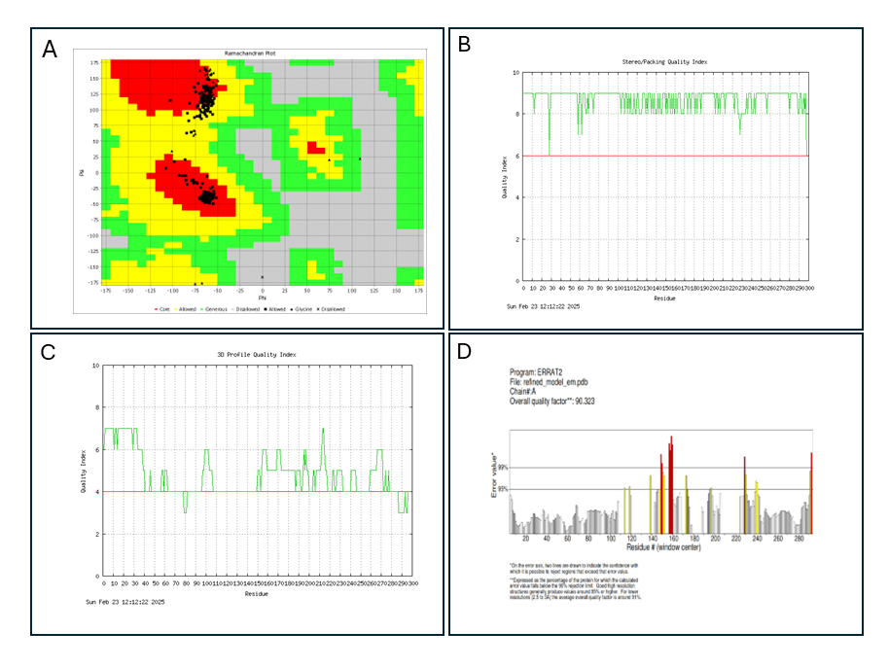
Figure 5. (A) Ramachandran plot, (B) Stereo/Packing Quality Index, (C) 3D Profile Quality Index, and (D) ERRAT plot of the refined vaccine model.

3.7. Vaccine Structure Molecular Docking
The refined model of the vaccine was docked by ClusPro 2.0 server against B7-1 (PDB ID 1DR9). According to the clustering scores and interaction energy, the best-docked complex was selected among the multiple models generated and illustrated in the figure 6.
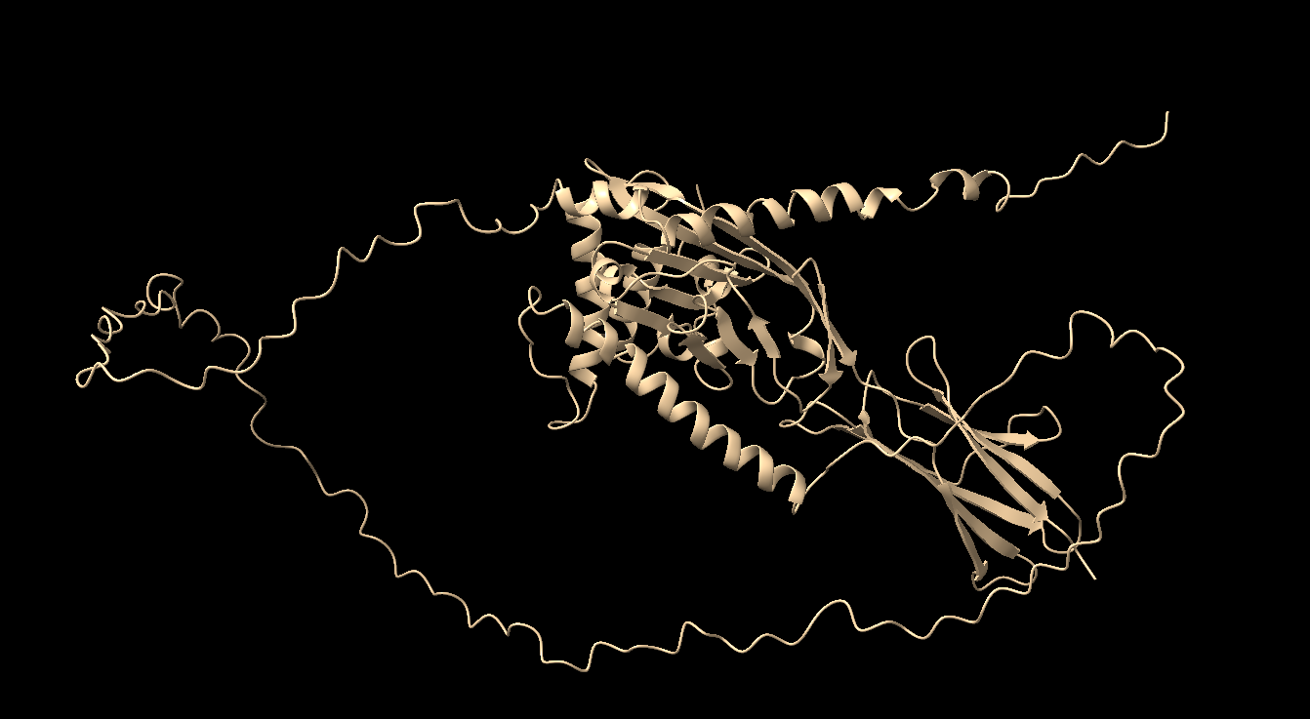
Figure 6. The best-docked complex model is illustrated in this figure.

3.8. Simulation Using Molecular Dynamics
Firstly, the simulation system's thermodynamic stability was assessed by observing temperature, density, potential energy, and pressure over the 100 ns trajectory through Gromacs Energies analysis in figure 7. A, B, C, and D. Analysis of the trajectory of the complexes was carried out to assess the stability and flexibility of the vaccine candidate. According to the root-mean-square deviation (RMSD) backbone plots, the system has reached a stable conformation with a low fluctuation after 80 ns in figure 8. A. The root-mean-square fluctuation (RMSF), the radius of gyration analysis (Rg), and hydrogen bonds were executed for the last 20 ns. This is the most reliable region in terms of system stability. In figure 8. B, the compactness of the receptor and vaccine over time is demonstrated by the Rg plot. The receptor maintained a relatively constant Rg value. It shows no significant unfolding or expansion. Moreover, the vaccine structure exhibited a relatively constant with a slightly higher Rg value. Considering the stable Rg values for both components further supports the conclusion that the complex remained structurally compact and stable throughout the simulation. In Figure 8. C, the RMSF plot highlights the flexibility of individual residues in the receptor and vaccine. The receptor showed lower RMSF values overall, indicating a more rigid structure. In contrast, the vaccine exhibited higher fluctuations in specific regions, particularly around residues 100-160 and 200-250, which may correspond to loop regions or flexible domains. In Figure 8. D, the hydrogen bond plot illustrates the number of hydrogen bonds that were formed between the receptor and vaccine over the simulation period. The number of hydrogen bonds remained relatively constant, averaging between 8 and 10, indicating a stable interaction interface. The consistent hydrogen bonding network suggests that the vaccine candidate forms strong and specific interactions with the receptor. This is crucial for the vaccine candidate's potential efficacy.
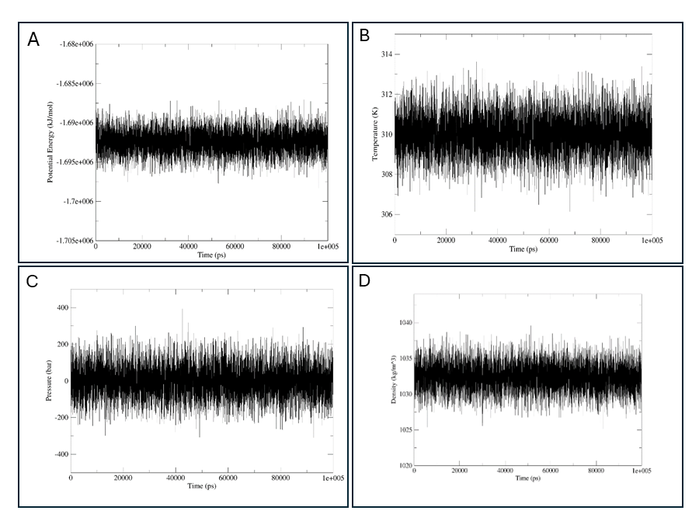
Figure 7. Thermodynamic analysis of the simulated system during the simulation time. (A) Potential energy, (B) Temperature, (C) Pressure, and (D) Density.
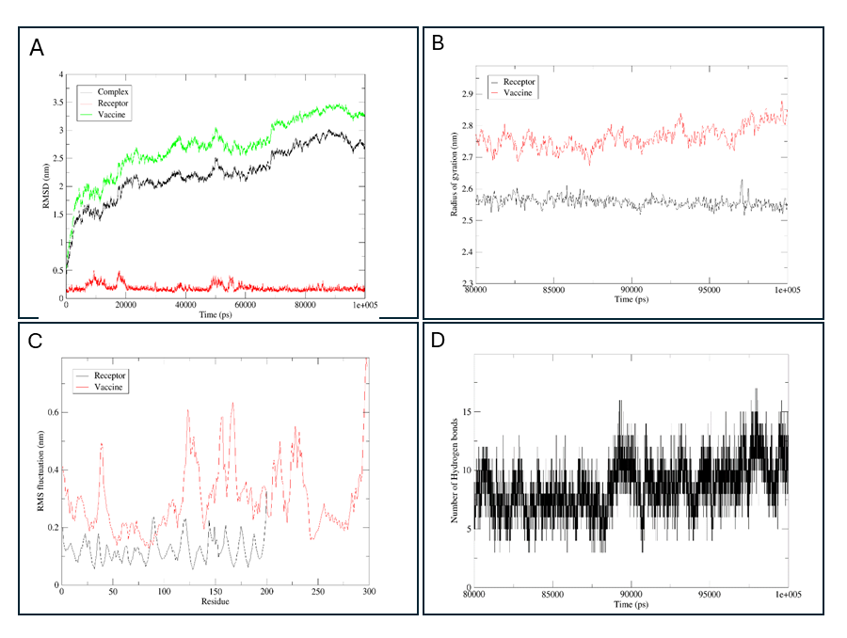
Figure 8. (A) The root-mean-square deviation (RMSD), (B) the Radius of Gyration plots of the vaccine and receptor, (C) The root-mean-square fluctuation (RMSF)of the vaccine and receptor, (D) The number of hydrogen bonds between vaccine and receptor.

4. Discussion
Pancreatic cancer is one of the most lethal human malignancies, with an increasing rate in recent years and expected to rise more in the future. Moreover, the challenge of early diagnosis and its resistance to chemotherapy and the immune system highlights the importance of this challenge and focuses on vaccine design for early intervention. Notably, Bioinformatic approaches make this process time-efficient and economical. This study focuses on finding a solution for pancreatic cancer by designing a multi-epitope vaccine construct targeting the TMOD3 protein, using bioinformatics web servers. In a previous study [18], a multi-epitope vaccine for pancreatic cancer was designed using immune-dominant epitopes obtained from the signature proteome in expression datasets. In another study [19], a novel multi-epitope vaccine construct against KRAS G12D and G12C mutants was designed utilizing reverse vaccinology and immunoinformatic approaches. This is due to the important role of mutant KRAS-induced tumorigenesis in the progression of pancreatic cancer and various other types of cancer including pancreatic, lung, and breast cancer. However, in this article, the TMOD3 protein is targeted for developing a vaccine against pancreatic cancer. Seven MHC class I, eight MHC class II, and one B cell epitope were selected for vaccine construction with AAY, GPGPG, and KK linkers, respectively. The C-terminal of Mycobacterium tuberculosis HSP70 with an EAAAK linker was added to the vaccine structure as an adjuvant to increase immunity. Additionally, to express and purify the protein, a 6x-His tag was added to the vaccine structure. The final construct of the multi-epitope vaccine including B cell epitope and MHC class I and II was evaluated from multiple aspects. Firstly, the quality of the vaccine construct was evaluated based on toxicity, allergenicity, and antigenicity features. Consequently, the vaccine structure using the web server consists of ToxinPred, AllerTop, and VaxiJen predicted structure is non-toxic, non-allergen, and antigen respectively. The chemical and physical properties and qualities of the structure were evaluated by the ProtParam webserver. The molecular weight of the vaccine structure is 31238.95 Daltons, which is acceptable quality. Particularly, the instability index of the vaccine construct 22.17 was which is less than 40 demonstrating the construct is stable. The Aliphatic index, which influences the temperature stability of protein, is 69.50 which represents a good result. The half-life of this vaccine structure was estimated more than 1 hour in mammalian, 2 min in yeast, and 2 min in Escherichia coli. Additionally, the other qualities were acceptable including, the theoretical pI, extinction coefficients, and GRAVY. In addition to this, the alpha helix index was estimated at 26.51% using the Prabi web server. After docking the refined vaccine model with B7-1, using the ClusPro 2.0 server the complex molecular dynamic simulation was evaluated. The 100 ns MD simulation and detailed structural and thermodynamic analysis, demonstrates strong evidence that the designed vaccine candidate against TMOD3 is structurally stable and forms a stable complex with the receptor. The findings emphasize the potential of the designed multi-epitope vaccine targeting TMOD3, for further development and experimental validation. More monitoring is required to focus on optimizing the vaccine design based on the identified flexible regions and conducting in vitro and in vivo studies to approve the immunogenicity and efficacy of the vaccine construct.

5. Conclusion
In this study, a novel multi-epitope vaccine construct against TMOD3 is developed and evaluated for its impact on the progression of Pancreatic Cancer. Moreover, the vaccine construct consists of 16 selected epitopes, including 7 MHC class I epitopes, 8 MHC class II epitopes, one B cell epitope, and an adjuvant. Bioinformatics and immunoinformatic analyses evaluated the quality and the secondary structures of the construct. It was demonstrated that the vaccine structure is non-allergenic, non-toxic, and possesses appropriate antigenic and physicochemical features. The structure was modelled and refined, and its quality was evaluated using multiple validation metrics. A 100 ns molecular dynamics simulation approved the structural stability of the vaccine candidate and its stable complex with the receptor. Although it requires more laboratory evaluation studies, it is anticipated that the suggested vaccine construct would be effective in preventing pancreatic cancer.

Funding
The author of this article did not receive funding from any funding agencies.

Conflict of Interest
The author declares no conflict of interest.

Non-financial Interests
The author declares no non-financial interests.

Acknowledgment
I would like to thank BioinfCamp.com for providing mentorship throughout this project, which had a key influence on the progress of this study.

Reference
[1] A. Pourshams et al., “The global, regional, and national burden of pancreatic cancer and its attributable risk factors in 195 countries and territories, 1990–2017: a systematic analysis for the Global Burden of Disease Study 2017,” Lancet Gastroenterol Hepatol, vol. 4, no. 12, p. 934, Dec. 2019, doi: 10.1016/S2468-1253(19)30347-4.
[2] X. Huang, G. Zhang, T. Tang, and T. Liang, “Identification of tumor antigens and immune subtypes of pancreatic adenocarcinoma for mRNA vaccine development,” Mol Cancer, vol. 20, no. 1, pp. 1–18, Dec. 2021, doi: 10.1186/S12943-021-01310-0/FIGURES/11.
[3] “(PDF) An Aging World: 2015.” Accessed: Dec. 06, 2024. [Online]. Available: https://www.researchgate.net/publication/299528572_An_Aging_World_2015
[4] S. Gillen, T. Schuster, C. M. Zum Büschenfelde, H. Friess, and J. Kleeff, “Preoperative/Neoadjuvant Therapy in Pancreatic Cancer: A Systematic Review and Meta-analysis of Response and Resection Percentages,” PLoS Med, vol. 7, no. 4, p. e1000267, Apr. 2010, doi: 10.1371/JOURNAL.PMED.1000267.
[5] B. Zhong et al., “Clinicopathological Characteristics, Prognosis, and Correlated Tumor Cell Function of Tropomodulin-3 in Pancreatic Adenocarcinoma,” Comb Chem High Throughput Screen, vol. 27, no. 7, pp. 1011–1021, Aug. 2024, doi: 10.2174/1386207326666230810142646.
[6] J. Parreno and V. M. Fowler, “Multifunctional roles of tropomodulin-3 in regulating actin dynamics,” Biophys Rev, vol. 10, no. 6, pp. 1605–1615, Dec. 2018, doi: 10.1007/S12551-018-0481-9.
[7] T. Stobdan, P. P. Jain, M. Xiong, V. Bafna, J. X. J. Yuan, and G. G. Haddad, “Heterozygous Tropomodulin 3 mice have improved lung vascularization after chronic hypoxia,” Hum Mol Genet, vol. 31, no. 7, pp. 1130–1140, Apr. 2022, doi: 10.1093/HMG/DDAB291.
[8] K. L. Weber, R. S. Fischer, and V. M. Fowler, “Tmod3 regulates polarized epithelial cell morphology,” J Cell Sci, vol. 120, no. Pt 20, pp. 3625–3632, Oct. 2007, doi: 10.1242/JCS.011445.
[9] B. Zhong et al., “Clinicopathological Characteristics, Prognosis, and Correlated Tumor Cell Function of Tropomodulin-3 in Pancreatic Adenocarcinoma,” Comb Chem High Throughput Screen, vol. 27, no. 7, p. 1011, Aug. 2024, doi: 10.2174/1386207326666230810142646.
[10] H. Zheng et al., “Tropomodulin 3 modulates EGFR-PI3K-AKT signaling to drive hepatocellular carcinoma metastasis,” Mol Carcinog, vol. 58, no. 10, pp. 1897–1907, Oct. 2019, doi: 10.1002/MC.23083.
[11] G. Pawlak et al., “Alterations in tropomyosin isoform expression in human transitional cell carcinoma of the urinary bladder,” Int J Cancer, vol. 110, no. 3, pp. 368–373, Jun. 2004, doi: 10.1002/IJC.20151.
[12] A. V. Paez et al., “Heme oxygenase-1 in the forefront of a multi-molecular network that governs cell-cell contacts and filopodia-induced zippering in prostate cancer,” Cell Death Dis, vol. 7, no. 12, 2016, doi: 10.1038/CDDIS.2016.420.
[13] D. Paul et al., “Global proteomic profiling identifies etoposide chemoresistance markers in non-small cell lung carcinoma,” J Proteomics, vol. 138, pp. 95–105, Apr. 2016, doi: 10.1016/J.JPROT.2016.02.008.
[14] H. Wang, G. Yang, Y. Yu, and P. Gu, “MicroRNA-490-3p suppresses the proliferation and invasion of hepatocellular carcinoma cells via targeting TMOD3,” Oncol Lett, vol. 20, no. 4, Oct. 2020, doi: 10.3892/OL.2020.11956.
[15] Z. He et al., “TMOD3 accelerated resistance to immunotherapy in KRAS-mutated pancreatic cancer through promoting autophagy-dependent degradation of ASCL4,” Drug Resistance Updates, vol. 78, p. 101171, Jan. 2025, doi: 10.1016/J.DRUP.2024.101171.
[16] X. Huang, G. Zhang, T. Y. Tang, X. Gao, and T. B. Liang, “Personalized pancreatic cancer therapy: from the perspective of mRNA vaccine,” Mil Med Res, vol. 9, no. 1, Dec. 2022, doi: 10.1186/S40779-022-00416-W.
[17] M. H. U. Masum, S. Wajed, M. I. Hossain, N. R. Moumi, A. Talukder, and M. M. Rahman, “An mRNA vaccine for pancreatic cancer designed by applying in silico immunoinformatics and reverse vaccinology approaches,” PLoS One, vol. 19, no. 7, p. e0305413, Jul. 2024, doi: 10.1371/JOURNAL.PONE.0305413.
[18] S. Banesh, N. Patil, V. R. Chethireddy, A. Bhukmaria, and P. Saudagar, “Design and evaluation of a multiepitope vaccine for pancreatic cancer using immune-dominant epitopes derived from the signature proteome in expression datasets,” Medical Oncology, vol. 41, no. 5, pp. 1–28, May 2024, doi: 10.1007/S12032-024-02334-4/METRICS.
[19] P. S. Ramalingam and S. Arumugam, “Reverse vaccinology and immunoinformatics approaches to design multi-epitope based vaccine against oncogenic KRAS,” Med Oncol, vol. 40, no. 10, Oct. 2023, doi: 10.1007/S12032-023-02160-0.
[20] I. Dimitrov, D. R. Flower, and I. Doytchinova, “AllerTOP - a server for in silico prediction of allergens,” BMC Bioinformatics, vol. 14, no. SUPPL6, pp. 1–9, Apr. 2013, doi: 10.1186/1471-2105-14-S6-S4/FIGURES/4.
[21] S. Gupta, P. Kapoor, K. Chaudhary, A. Gautam, R. Kumar, and G. P. S. Raghava, “In Silico Approach for Predicting Toxicity of Peptides and Proteins,” PLoS One, vol. 8, no. 9, p. e73957, Sep. 2013, doi: 10.1371/JOURNAL.PONE.0073957.
[22] I. A. Doytchinova and D. R. Flower, “VaxiJen: A server for prediction of protective antigens, tumour antigens and subunit vaccines,” BMC Bioinformatics, vol. 8, no. 1, pp. 1–7, Jan. 2007, doi: 10.1186/1471-2105-8-4/TABLES/2.
[23] R. Vita et al., “The Immune Epitope Database (IEDB): 2018 update,” Nucleic Acids Res, vol. 47, no. D1, pp. D339–D343, 2019, doi: 10.1093/NAR/GKY1006.
[24] R. Saha, P. Ghosh, and V. L. S. P. Burra, “Designing a next generation multi-epitope based peptide vaccine candidate against SARS-CoV-2 using computational approaches,” 3 Biotech, vol. 11, no. 2, pp. 1–14, Feb. 2021, doi: 10.1007/S13205-020-02574-X/FIGURES/6.
[25] M. Li et al., “Design of a multi-epitope vaccine candidate against Brucella melitensis,” Sci Rep, vol. 12, no. 1, Dec. 2022, doi: 10.1038/S41598-022-14427-Z.
[26] P. S. Ramalingam and S. Arumugam, “Reverse vaccinology and immunoinformatics approaches to design multi-epitope based vaccine against oncogenic KRAS,” Med Oncol, vol. 40, no. 10, Oct. 2023, doi: 10.1007/S12032-023-02160-0.
[27] C. Ge et al., “Key interactions in the trimolecular complex consisting of the rheumatoid arthritis-associated DRB1*04:01 molecule, the major glycosylated collagen II peptide and the T-cell receptor,” Ann Rheum Dis, vol. 81, no. 4, p. 480, 2022, doi: 10.1136/ANNRHEUMDIS-2021-220500.
[28] A. P. Bidkar, K. K. Thakur, N. B. Bolshette, J. Dutta, and R. Gogoi, “In-silico Structural and Functional Analysis of Hypothetical Proteins of Leptospira Interrogans,” Biochem Pharmacol, vol. 3, no. 3, p. 136, 2014, doi: 10.4172/2167-0501.1000136.
[29] M. N. Tazehkand, “In silico design and analysis of recombinant vaccine against Clostridium perfringens Type A and Type E.,” Suleyman Demirel University The Journal of Health Science, vol. 11, no. 2, pp. 138–143, Jun. 2020, doi: 10.22312/SDUSBED.680719.
[30] C. Combet, C. Blanchet, C. Geourjon, and G. Deléage, “NPS@: network protein sequence analysis,” Trends Biochem Sci, vol. 25, no. 3, pp. 147–150, Mar. 2000, doi: 10.1016/S0968-0004(99)01540-6.
[31] J. Jumper et al., “Highly accurate protein structure prediction with AlphaFold,” Nature, vol. 596, no. 7873, pp. 583–589, Aug. 2021, doi: 10.1038/S41586-021-03819-2.
[32] J. Ko, H. Park, L. Heo, and C. Seok, “GalaxyWEB server for protein structure prediction and refinement,” Nucleic Acids Res, vol. 40, no. W1, pp. W294–W297, Jul. 2012, doi: 10.1093/NAR/GKS493.
[33] C. Colovos and T. O. Yeates, “Verification of protein structures: patterns of nonbonded atomic interactions,” Protein Sci, vol. 2, no. 9, pp. 1511–1519, 1993, doi: 10.1002/PRO.5560020916.
[34] J. U. Bowie, R. Lüthy, and D. Eisenberg, “A method to identify protein sequences that fold into a known three-dimensional structure,” Science, vol. 253, no. 5016, pp. 164–170, Jul. 1991, doi: 10.1126/SCIENCE.1853201.
[35] R. Lüthy, J. U. Bowie, and D. Eisenberg, “Assessment of protein models with three-dimensional profiles,” Nature, vol. 356, no. 6364, pp. 83–85, 1992, doi: 10.1038/356083A0.
[36] J. Pontius, J. Richelle, and S. J. Wodak, “Deviations from standard atomic volumes as a quality measure for protein crystal structures,” J Mol Biol, vol. 264, no. 1, pp. 121–136, Nov. 1996, doi: 10.1006/JMBI.1996.0628.
[37] X. Guo, X. Pan, Q. Sun, Y. Hu, and J. Shi, “Design of a novel multiepitope vaccine against Chlamydia pneumoniae using the extracellular protein as a target,” Sci Rep, vol. 13, no. 1, Dec. 2023, doi: 10.1038/S41598-023-42222-X.
[38] I. T. Desta, K. A. Porter, B. Xia, D. Kozakov, and S. Vajda, “Performance and Its Limits in Rigid Body Protein-Protein Docking,” Structure, vol. 28, no. 9, pp. 1071-1081.e3, Sep. 2020, doi: 10.1016/J.STR.2020.06.006.
[39] G. Jones et al., “Elucidation of protein function using computational docking and hotspot analysis by ClusPro and FTMap,” Acta Crystallogr D Struct Biol, vol. 78, no. Pt 6, p. 690, Jun. 2022, doi: 10.1107/S2059798322002741.
[40] S. Vajda et al., “New additions to the ClusPro server motivated by CAPRI,” Proteins, vol. 85, no. 3, pp. 435–444, Mar. 2017, doi: 10.1002/PROT.25219.
[41] D. Kozakov et al., “The ClusPro web server for protein-protein docking,” Nat Protoc, vol. 12, no. 2, pp. 255–278, Feb. 2017, doi: 10.1038/NPROT.2016.169.
[42] D. Kozakov et al., “How good is automated protein docking?,” Proteins, vol. 81, no. 12, pp. 2159–2166, Dec. 2013, doi: 10.1002/PROT.24403.
[43] M. J. Abraham et al., “GROMACS: High performance molecular simulations through multi-level parallelism from laptops to supercomputers,” SoftwareX, vol. 1–2, pp. 19–25, Sep. 2015, doi: 10.1016/J.SOFTX.2015.06.001.

